- Launch one EC2 using Amazon Linux 2 image and add a script in user data to install Apache:-
- Login to AWS Console
- Open AWS Management Console.
- Navigate to EC2 Dashboard.
- Launch a New EC2 Instance
- Click Launch Instance.
- Provide an instance name.
- Choose Amazon Machine Image (AMI)
- Select Amazon Linux 2 as the operating system image.
- AMI contains the OS and preconfigured software.
- Select Instance Type
- Choose an instance type (e.g., t2.micro).
- Instance type determines CPU, memory, and storage capacity.
- Configure Key Pair
- Create or select an existing key pair (.pem file).
- Used for secure SSH access to the EC2 instance.
- Configure Network and Security Group
- Allow:
- SSH (Port 22) → For remote login
- HTTP (Port 80) → For Apache web access
- Security groups act as virtual firewalls.
- Add Storage
- Allocate required storage (default EBS volume or custom size).
- Add User Data Script
- Open Advanced Details → User Data.
- Add commands to:
- Update packages
- Install Apache (httpd)
- Start Apache service
- Enable Apache service on reboot
- User data executes automatically during the first boot.
- Review and Launch Instance
- Verify all configurations.
- Click Launch Instance.
- Wait for Instance Initialization
- EC2 moves to Running state.
- Status checks should pass (2/2).
- Verify Apache Installation
- Access instance public IP in browser.
- Apache default page or custom webpage should appear.
- Monitor User Data Execution
- Check logs (cloud-init) to confirm script execution.
- Troubleshoot if Apache installation fails.
Launch EC2
↓
Select Amazon Linux 2 AMI
↓
Configure Instance + Security Group
↓
Add User Data Script
↓
Launch Instance
↓
User Data Executes Automatically
↓
Apache Installed & Started
↓
Access Web Server via Public IP

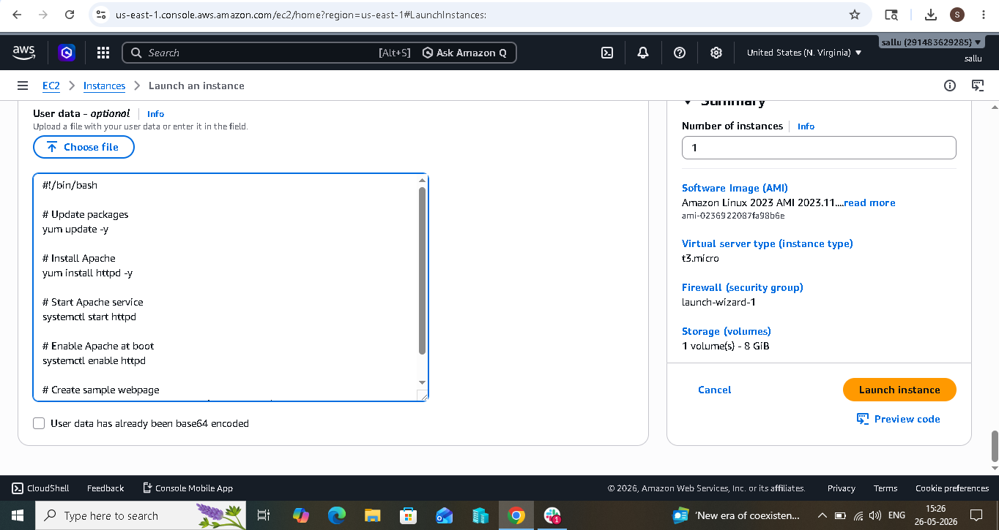
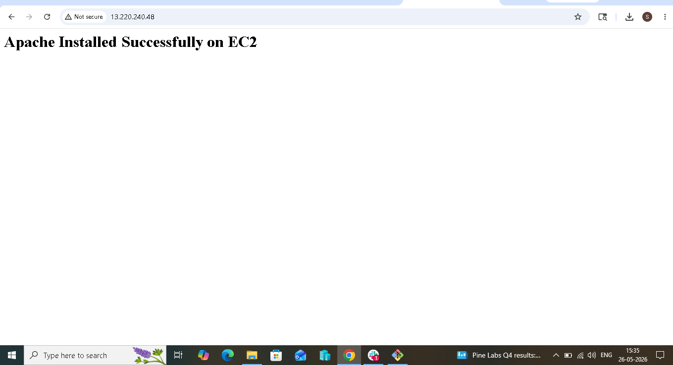
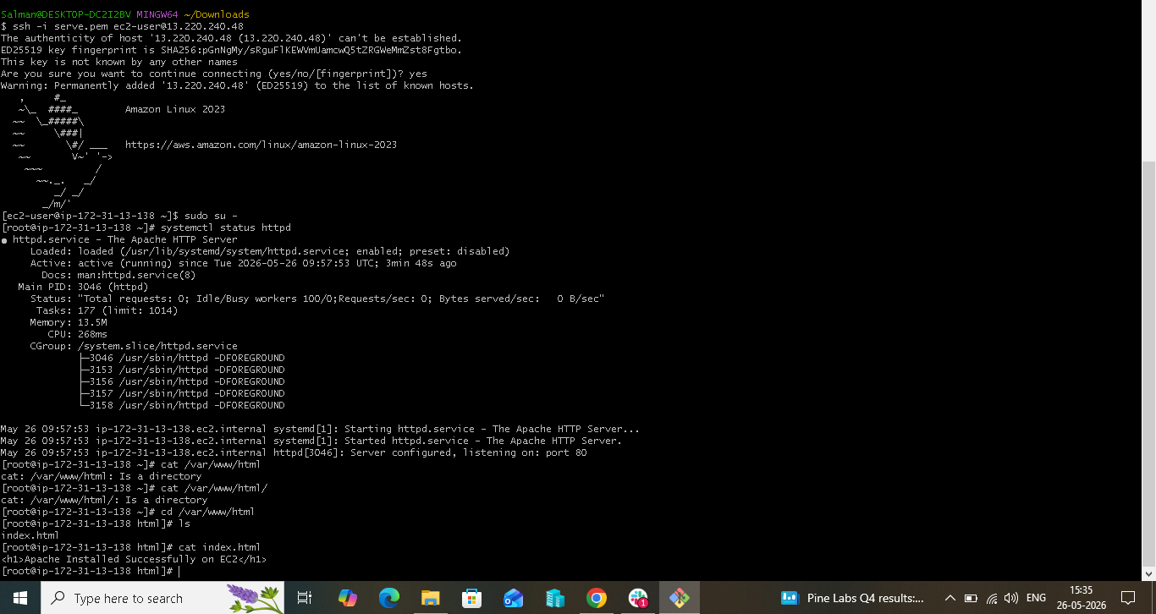

- Launch one EC2 using Ubuntu image and add a script in user data to install Nginx:-
- Login to AWS Console
- Open AWS Management Console.
- Navigate to EC2 Dashboard.
- Launch a New EC2 Instance
- Click Launch Instance.
- Enter an instance name.
- Choose Amazon Machine Image (AMI)
- Select Ubuntu Server image.
- Ubuntu provides apt package manager for software installation.
- Select Instance Type
- Choose instance type (e.g., t2.micro).
- Determines CPU, RAM, and performance.
- Create or Select Key Pair
- Choose existing key pair or create new .pem key.
- Used for SSH access to the instance.
- Configure Security Group
- Allow:
- SSH (22) → Remote login
- HTTP (80) → Access Nginx webpage
- (Optional) HTTPS (443) → Secure web traffic
- Configure Storage
- Select required storage size (default EBS or custom).
- Add User Data Script
- Open Advanced Details → User Data.
- Add script to:
- Update packages
- Install Nginx
- Start Nginx service
- Enable Nginx at boot
- User data runs automatically during first startup.

- Example user data script:

- #!/bin/bash
- apt update -y
- apt install nginx -y
- systemctl start nginx
- systemctl enable nginx
- echo "<h1>Nginx Installed Successfully</h1>" > /var/www/html/index.nginx-debian.html
- Review Configuration
- Verify AMI, security groups, storage, and user data.
- Launch EC2 Instance
- Click Launch Instance.
- Wait for Instance Status Checks
- Instance should reach:
- Running (2/2 status checks passed)
- Verify Nginx Installation
- Open browser:
- http://<Public-IP>
- Nginx webpage should appear.
- Check User Data Execution Logs (Optional)

- SSH into instance:

Workflow:
Launch EC2
↓
Select Ubuntu AMI
↓
Configure Instance + Security Group
↓
Add User Data Script
↓
Launch Instance
↓
User Data Executes Automatically
↓
Nginx Installed & Started
↓
Access Web Server using Public IP

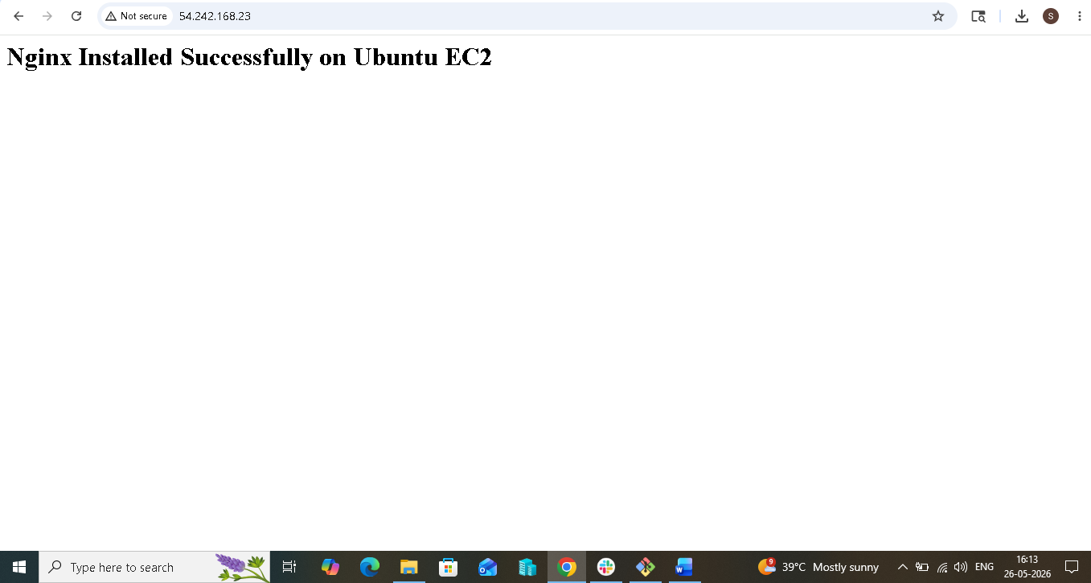

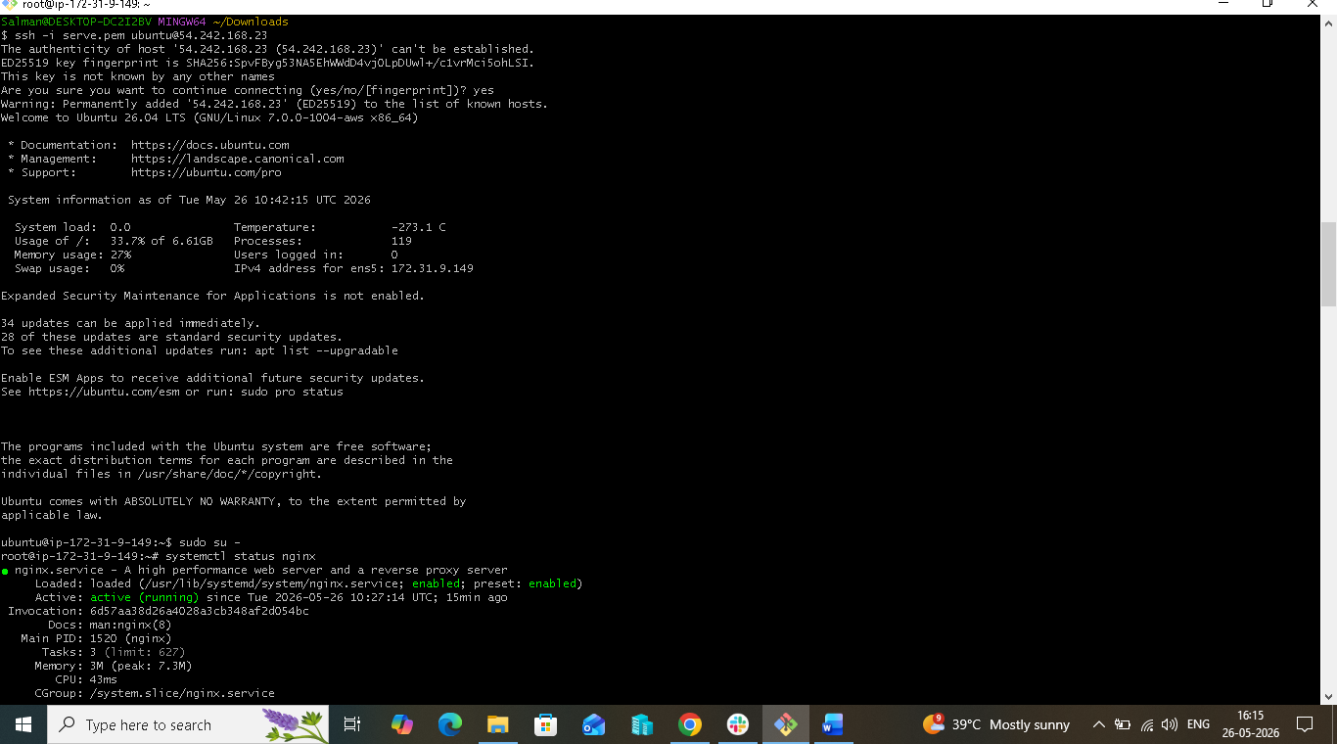

3. Launch one Windows server and install Tomcat on Windows:-
To launch an instance of windows image and
install tomcat on that remote computer instance that we
have launched.
STEP BY STEP IMPLEMENTATION:
- Create a instance on aws by selecting a Microsoft image and
the selected image is free tier.
- Create a key pair that is used to connect with the remote
Computer
- After launching that instance, search for the desktop remote
connection to connect with that created instance.
- For this, search for the desktop remote connection in our local
machine.
- Here, we have to give the computer name that is available in
our created instance -> ec2-13-222-138-
162.compute-1.amazonaws.com
- Then will give the user name -> administrator
- Then we have to give the password, to get that password click
on get password then it will ask for the .pem file key
- Copy that key content and paste it here, it will decrypt that
key and give the password for.
- Then copy that decrypted key, use that key to connect with
remote desktop.
By this process, we will able to connect with remote desktop.
- To install tomcat, java is the prerequisite for the tomcat. So
download java from the browser.
- After downloading java, download tomcat from the browser.
Then go to command prompt of that remote computer

- First of all, search for the java path -> where java
- After getting that path of java, copy that path and set that path
for tomcat identification
- By using set command, we can set the path of the java for
temporary -> set JAVA_HOME=”path”
- Then extract the downloaded zip file of tomcat by right
clicking the click on extract all.
- Now the extracted file will available and it will be used to
start the tomcat service in the browser.
- Use the command to start the tomcat service -> startup.bat.
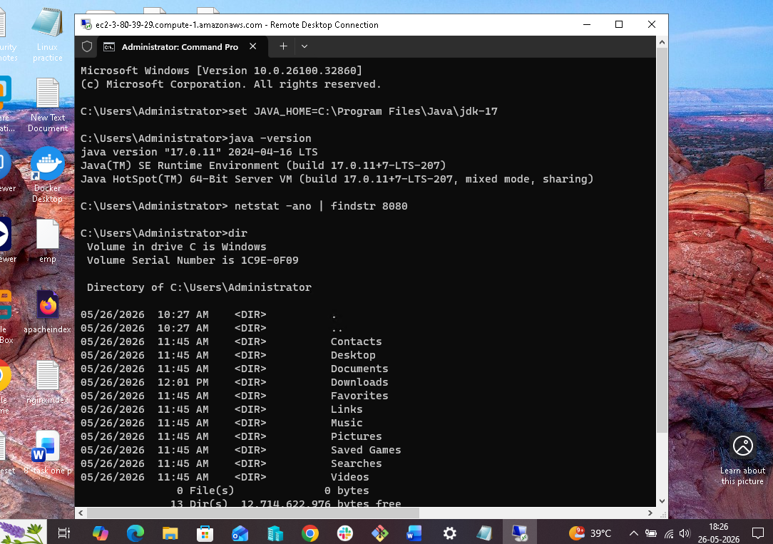

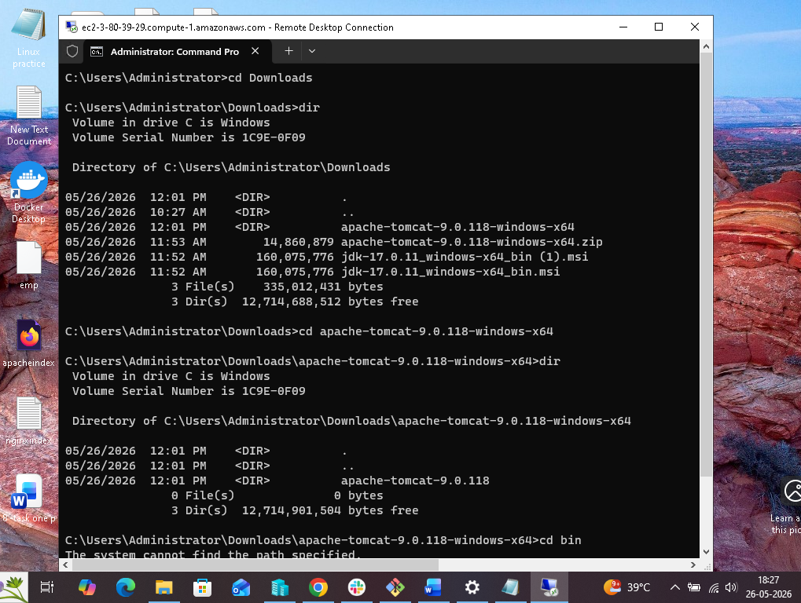
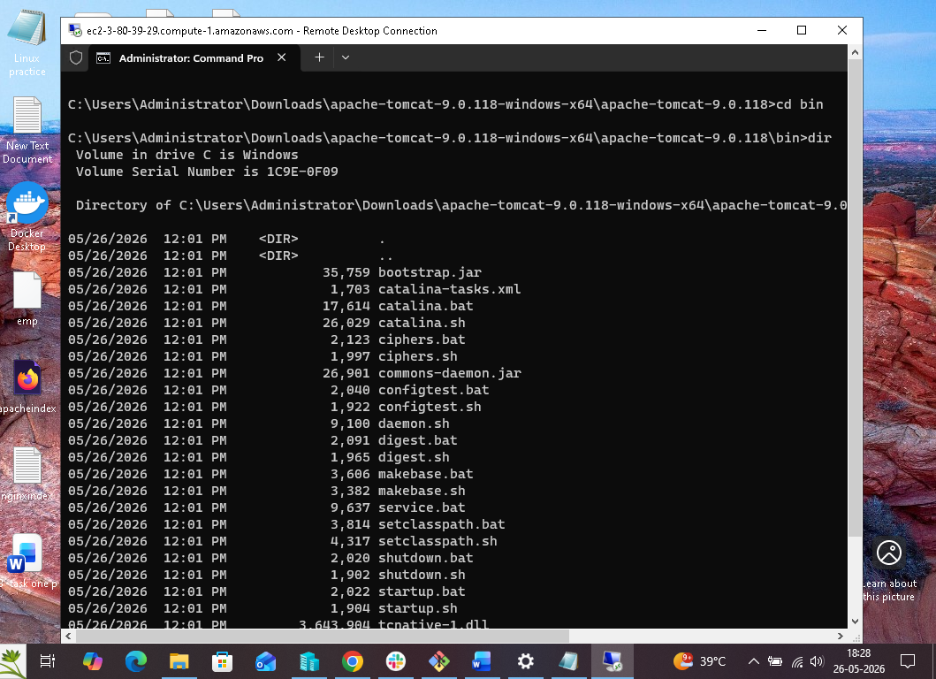
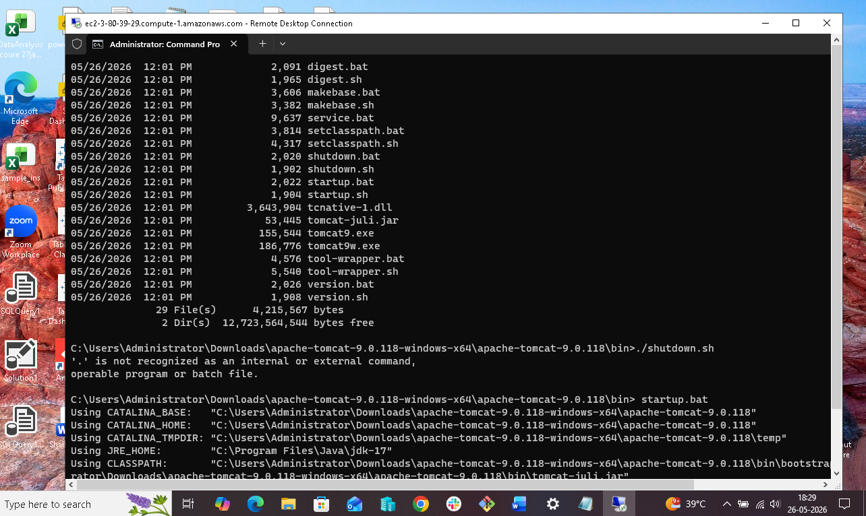
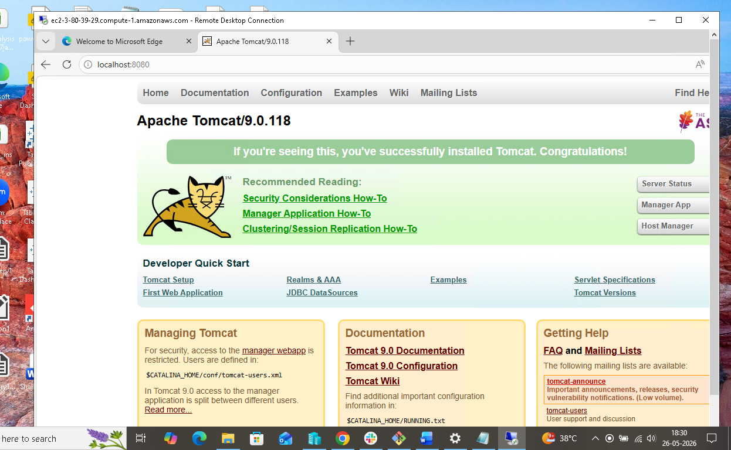

4.Take a snapshot of the instance created in Task 1:-
Objective

- Create a snapshot (backup) of the EC2 instance launched in Task-1 (Amazon Linux 2 with Apache installed).

- A snapshot stores the data of the attached EBS volume and can be used later for recovery or creating new volumes.

- Prerequisites

- Before taking a snapshot, ensure:

- EC2 instance is already created
- Apache installed through User Data
- Instance is in Running state
- Outcome / Result

- Successfully created a snapshot of the EC2 instance volume.

- The snapshot can be used for:

- Data backup
- Disaster recovery
- Creating new EBS volumes
- Restoring server data
- Conclusion

- An EBS snapshot of the Amazon Linux 2 EC2 instance was created successfully. The snapshot serves as a backup and helps recover or recreate storage whenever required.

- This is a documentation style usually acceptable for DevOps/AWS assignments.AWS Console access available.

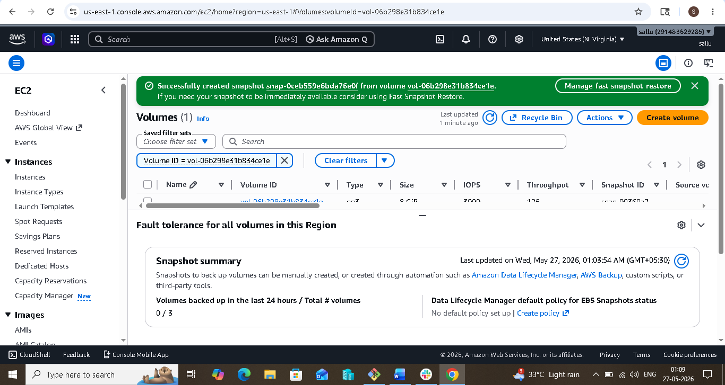

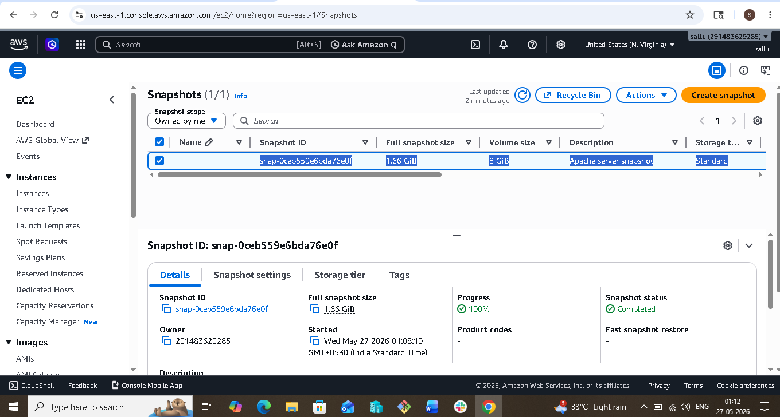

5. Assign passwordless authentication for the EC2 created in Task 2:-

Objective:

Configure passwordless SSH authentication for the Ubuntu EC2 instance created in Task 2, allowing secure login without entering a password repeatedly.

Step 1: Login to AWS EC2 Instance
Open terminal or command prompt.
Connect to the Ubuntu EC2 instance using the downloaded .pem key file.
This key is used for the initial secure access to the server.

Purpose:
To access the EC2 server and perform SSH configuration.

Step 2: Verify Existing SSH Keys
Check whether SSH keys already exist in the system.
SSH keys are stored inside the .ssh directory.

Purpose:
To determine whether a new key pair must be generated.

Step 3: Generate SSH Key Pair
Create an SSH key pair using SSH key generation command.
Two files are created:
Private Key: Used by client machine to authenticate.
Public Key: Added to the target server for authentication.

Purpose:
To establish secure key-based communication between client and server.

Step 4: Copy Public Key to EC2 Instance
Add the generated public key into the EC2 instance.
Public keys are stored in the authorized_keys file inside the .ssh directory.

Purpose:
Allows the server to recognize and trust requests from the matching private key.

Step 5: Configure SSH Directory Permissions
Assign proper permissions to:
.ssh directory
authorized_keys file

Purpose:
SSH requires strict permissions for security; otherwise authentication may fail.

Step 6: Verify Authorized Keys Configuration
Confirm that the public key has been successfully added to authorized_keys.

Purpose:
Ensures the server can validate incoming SSH requests.

Step 7: Test Passwordless Authentication
Logout from the EC2 instance.
Attempt to reconnect using SSH.
The server should authenticate automatically without asking for password.

Purpose:
To verify successful passwordless login configuration.

Step 8: Disable Password Authentication (Optional)
Modify SSH configuration file.
Disable password-based login and enable public key authentication only.

Purpose:
Improves server security by preventing password-based attacks.

Step 9: Restart SSH Service
Restart SSH daemon after making configuration changes.

Purpose:
Applies updated SSH settings.

Step 10: Validate Successful Configuration
Reconnect to the server and confirm login occurs through SSH keys.
Authentication logs can be checked if issues occur.

Purpose:
Final verification of passwordless authentication setup.

Outcome:

Passwordless SSH authentication is successfully configured on the Ubuntu EC2 instance, enabling secure access using SSH keys instead of passwords.

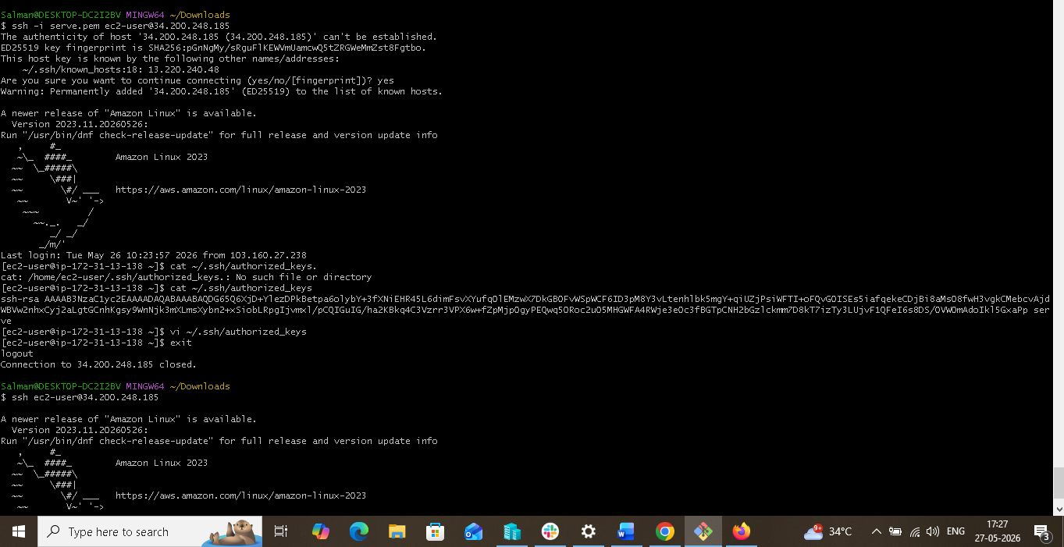

6. Launch any EC2 using the spot purchasing option:-

Objective:

Launch an EC2 instance using the Spot Instance purchasing option, which allows using unused AWS capacity at lower cost compared to On-Demand instances.

Step 1: Login to AWS Console
Open browser.
Go to AWS Management Console.
Sign in using AWS account credentials.

Purpose:
Access AWS services.

Step 2: Open EC2 Dashboard
Search for EC2 in AWS search bar.
Click EC2 service.
EC2 Dashboard opens.

Purpose:
Manage virtual servers (instances).

Step 3: Launch New Instance
In EC2 Dashboard, click:
Launch Instance

Purpose:
Start creating a new virtual machine.

Step 4: Enter Instance Name
Under Name and tags
Provide instance name.

Example:

Spot-Instance-Server

Purpose:
Helps identify the instance.

Step 5: Choose Amazon Machine Image (AMI)

Select operating system.

Examples:

Amazon Linux
Ubuntu
Red Hat
Windows

Example:

Ubuntu Server 24.04 LTS

Purpose:
Defines operating system for EC2.

Step 6: Select Instance Type

Choose instance size.

Example:

t2.micro

(Eligible for free tier in some cases)

Purpose:
Determines CPU and RAM.

Step 7: Select Key Pair

Choose existing key pair or create new key pair.

Download:

.pem file

Purpose:
Used for SSH login into EC2.

Step 8: Configure Network Settings

Allow required inbound traffic.

Add security group rules:

Type Port Purpose
SSH 22 Remote login
HTTP 80 Web access
HTTPS 443 Secure web access

Purpose:
Controls access to EC2.

Step 9: Configure Storage

Choose storage size.

Example:

8 GB (default)

Increase if needed.

Purpose:
Disk space for server.

Step 10: Select Spot Purchasing Option

Go to:

Advanced Details

Find:

Purchasing Option

Choose:

Request Spot Instances

Enable:

✓ Request Spot Instance

(Optional)

Set maximum price:

Leave default (recommended)

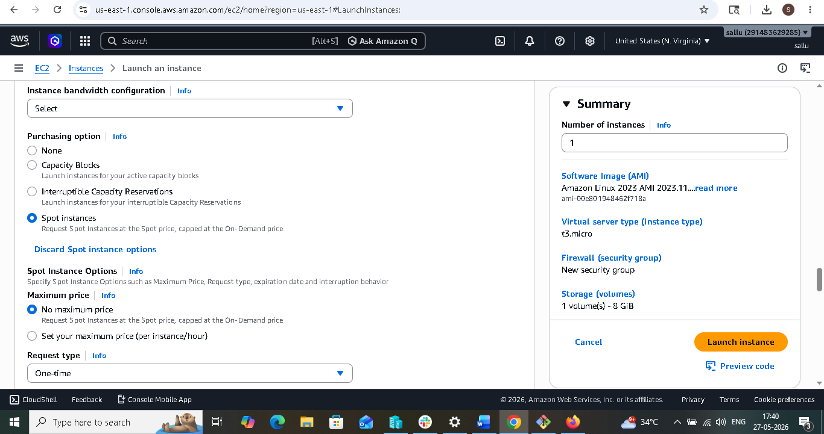

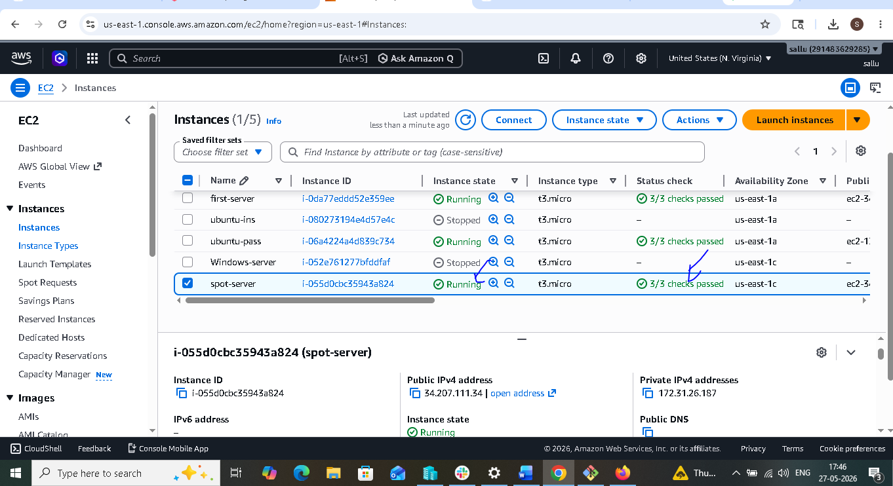

7. Enable termination policy on the EC2 created in Task 2:-

Objective:

Enable termination protection for the EC2 instance to prevent accidental deletion or termination of the server.

Step 1: Login to AWS Management Console
Open AWS Management Console in a web browser.
Sign in using AWS credentials.

Purpose:
Access AWS services and manage EC2 resources.

Step 2: Open EC2 Dashboard
Search for EC2 in the AWS search bar.
Open the EC2 Dashboard.
Navigate to Instances.

Purpose:
View and manage available EC2 instances.

Step 3: Select the Required EC2 Instance
Identify the Ubuntu EC2 instance created in Task 2.
Select the instance by clicking the checkbox beside it.

Purpose:
Choose the specific server on which termination protection must be enabled.

Step 4: Open Instance Settings
Click Actions.
Select Instance settings.
Choose Change termination protection.

Purpose:
Access termination protection configuration settings.

Step 5: Enable Termination Protection
In the configuration window, select Enable.
Save the changes.

Purpose:
Prevents accidental termination of the EC2 instance.

Step 6: Verify Termination Protection Status
Open the Details section of the selected instance.
Check the status of Termination Protection.

Expected status:

Termination Protection = Enabled

Purpose:
Ensure the configuration has been applied successfully.

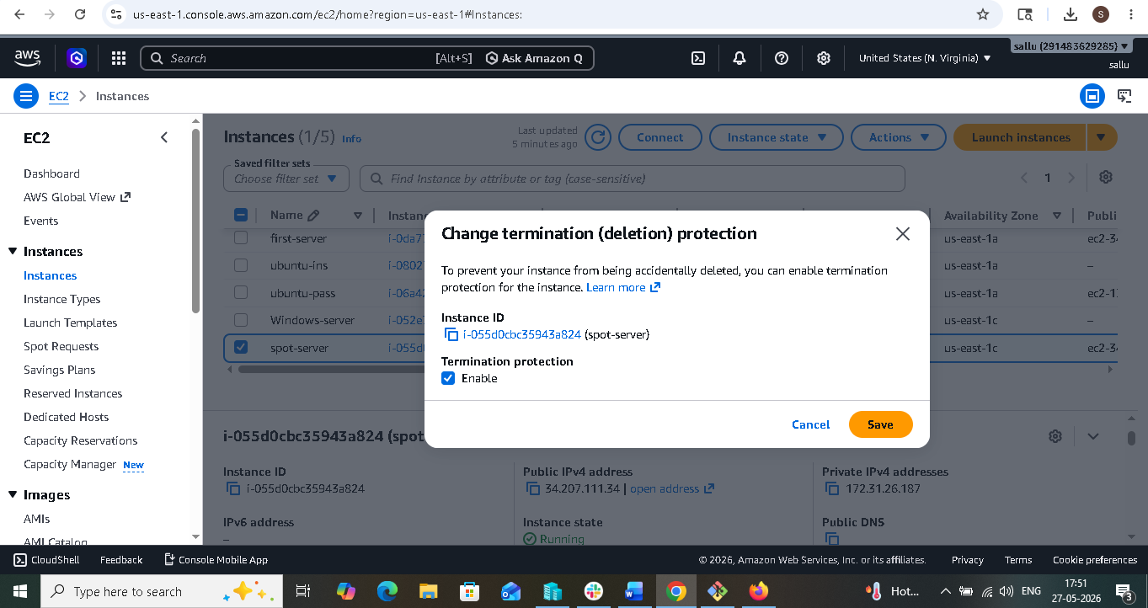

8. Launch one EC2 using AWS CLI:-

- Launch https://aws.amazon.com/ on browser.
- Sign in as a root user with the email address and password.
- Search for IAM in search bar.
- Select IAM.
- Click on IAM users under access management.
- Click on create user.
- User name is listed under IAM users list page.
- Select the created user.
- Click on create access key.
- Select CLI as usecase.
- Click next
- Click on create access key.
- Notice that the access key is created and user is navigated to
- retrieve access key page.
- Now open git bash on your local machine.
- Aws - - version to check the aws version.
- Mention aws configure command.
- Enter access key and secret key, location: us-east-1 and output
- format: json.
- aws ec2 describe-security-groups
- "GroupId": " sg-0abd93266585aa027"
- Launch ec2 instance using
- aws ec2 run-instances \
- --image-id ami-091138d0f0d41ff90 \
- --count 1 \
- --instance-type t3.micro \
- --key-name keys \
- --security-group-ids sg-0abd93266585aa027 \
- --subnet-id subnet-6e7f829e
- aws ec2 describe-instances --output table
- navigate back aws ec2 instance page.
- Observe that instance is running.

